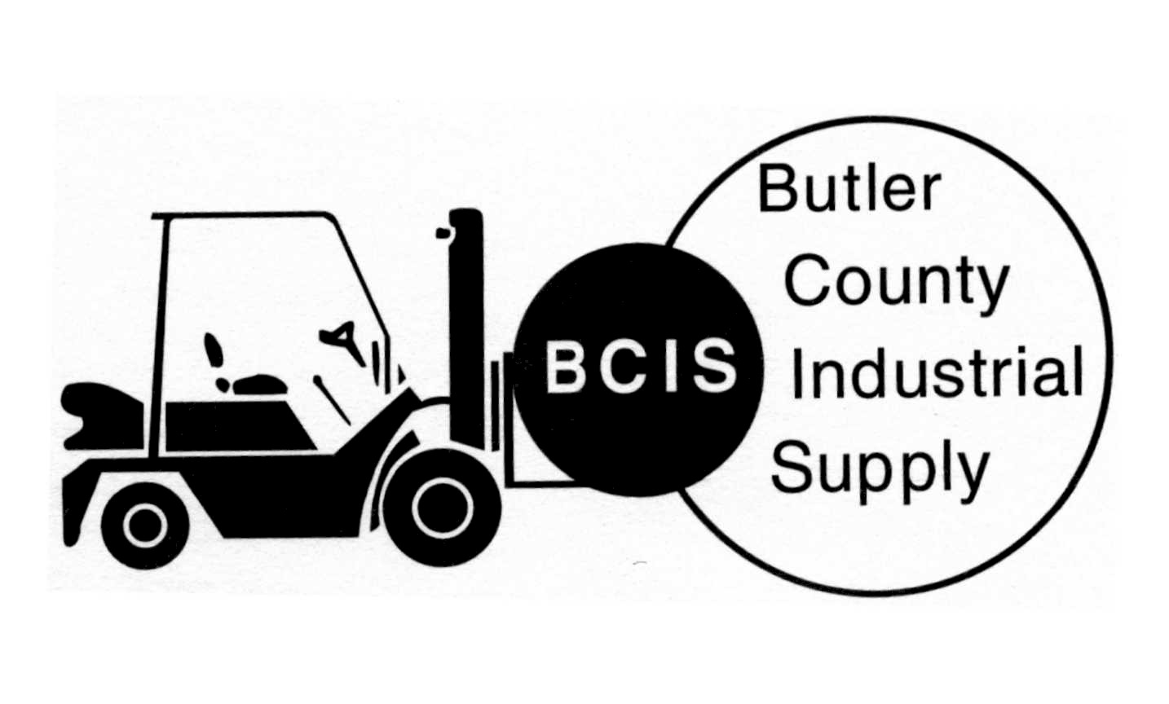

POWERED INDUSTRIAL TRUCK “TRAIN THE TRAINER” REGISTRATION

SCHEDULED CLASS DATE: ___________________
LOCATION: BCIS, INC.
4700 INDUSTRY DRIVE
FAIRFIELD, OHIO 45014

REGISTRATION: $ 495.00/EACH (special price)

QUANTITY: _____________________ TOTAL: $________________

NAME: ______________________________________________________________________

TITLE: _______________________________________________________________________

COMPANY: ___________________________________________________________________

COMPANY ADDRESS: _________________________________________________________

CITY: _______________________________ STATE: _________________ ZIP ____________

TELEPHONE: _____________________________________ FAX: _______________________

*ALL REGISTRATION FORMS AND PAYMENT MUST BE RECEIVED PRIOR
TO CLASS DATE.

______________________________________ _____________________________
AUTHORIZED SIGNATURE DATE

SEND TO: BCIS INC.
4700 INDUSTRY DRIVE
FAIRFIELD, OHIO 45014
-OR –
FAX TO: 513-829-1950

